**CIV E 601**

**TERM PROJECT**

**Progress Report**



**Presented By:**

**Lily Ren, Suzana Trac, Haoran Liang, Owen Zhao**

# Introduction

Group 7 (previously Group 8) is pleased to submit the following update per the ‘Term Project Statement and Specifications’ document uploaded on e-class. The update includes both a proposal outlining the approach to be employed in addressing the provided problem statement in addition to a high-level update on the work completed to date. The group is excited about the opportunity to work on the term project.

# Project Understanding

Based on the information provided to the class as shared on e-class, it is the team’s understanding that project management services are required to assist in the planning and scheduling of multiple projects within a specified time frame considering resource constraints.

Two assignments have been specified in the ‘Term Project Statement and Specifications’ document; one with 85 projects of differing durations, sites, ready dates, deadlines, and priorities (Assignment A), in addition to another with 20 projects in which contracts stipulate payment penalties and liquidated damages, should delays be incurred past the completion deadline (Assignment B). Both assignments require the scheduling of as many projects as feasible and practical, in the best interest of the client organization, per deadlines and priorities in Assignment A, and to minimize delay costs per Assignment B.

The final report detailing the approach, solution, results, and recommendations is to be completed for December 1, 2023, or sooner, with a video presentation recorded and submitted by November 22, 2023, at the latest.

# Project Methodology

The following is a brief outline of the services that the group will provide based on the term project deliverables and timelines specified by the class instructor and Teaching Assistant (TA):

## Phase 1 (October 1, 2023 to October 15, 2023)

Scope of Work:

* Initial meeting to review ‘Term Project Statement and Specifications’ document and establish project scope (completed)
* Determine applicable methods/techniques for multi-project scheduling/planning (in progress)
* Development of deliverables to be submitted to the instructor and TA

Deliverables:

* Preparation and submission of Project Update 1 by October 11, 2023
* Gantt chart in scheduling application to visualize durations and timelines for both assignments

## Phase 2 (October 16, 2023 to November 5, 2023)

Scope of Work:

* Selection of analytical method(s) to be employed in addressing questions related to both assignments, including applicable verification techniques
* Execution of appropriate analytical method(s), including creation of an application(s), if required, to schedule projects in both assignments
* Development of deliverables to be submitted to the instructor and TA

Deliverables:

* Preparation and submission of Project Update 2 by November 2, 2023
* Draft project schedule outlining projects to be carried out, in addition to the applicable timelines
* Rough draft of Final Report content related to analytical methods considered, and rationale in selection of utilized techniques, as well as preliminary analysis results

## Phase 3 (November 6, 2023 to December 1, 2023)

Scope of Work:

* Verify scheduling results obtained from Phase 2
* Development of deliverables to be submitted to the instructor and TA

Deliverables:

* Finalized project schedule outlining projects to be carried out, in addition to the applicable timelines
* Outputs from verification of scheduling results
* Preparation and submission of Final Presentation by November 22, 2023
* Preparation and submission of Final Report by December 1, 2023

# Project Update (Work to Date)

We first imported the project data, including Date Ready (Early Start) and Deadline (Late Finish), Duration, and Priority Index into a Google Sheet and filtered by priority to generate a list of projects ranked by project priority. This list is then fed into SmartSheets (due to University of Alberta students not having access to Microsoft Project Online via our Microsoft 365 licenses) to generate a Gantt chart view so that we can best understand which projects should be prioritized within the first three-week planning horizon. Please see Figure 1A and 1B below for the initial Gantt chart output.

By visually examining the initial Gantt chart, we have set up a Google Sheet formula to automatically deduct the number of days (Duration) of each project from each Crew’s availability. Separate Gantt charts for each crew will be created once the scheduling and resource management has been determined and optimized.

We need to better understand if there is any relationship between Assignment A and Assignment B, or if it’s a separate question as the instructions unclear.

*Figure 1A. Quick Gantt Chart of Provided Dates in Assignment A (Early Start to Late Finish)*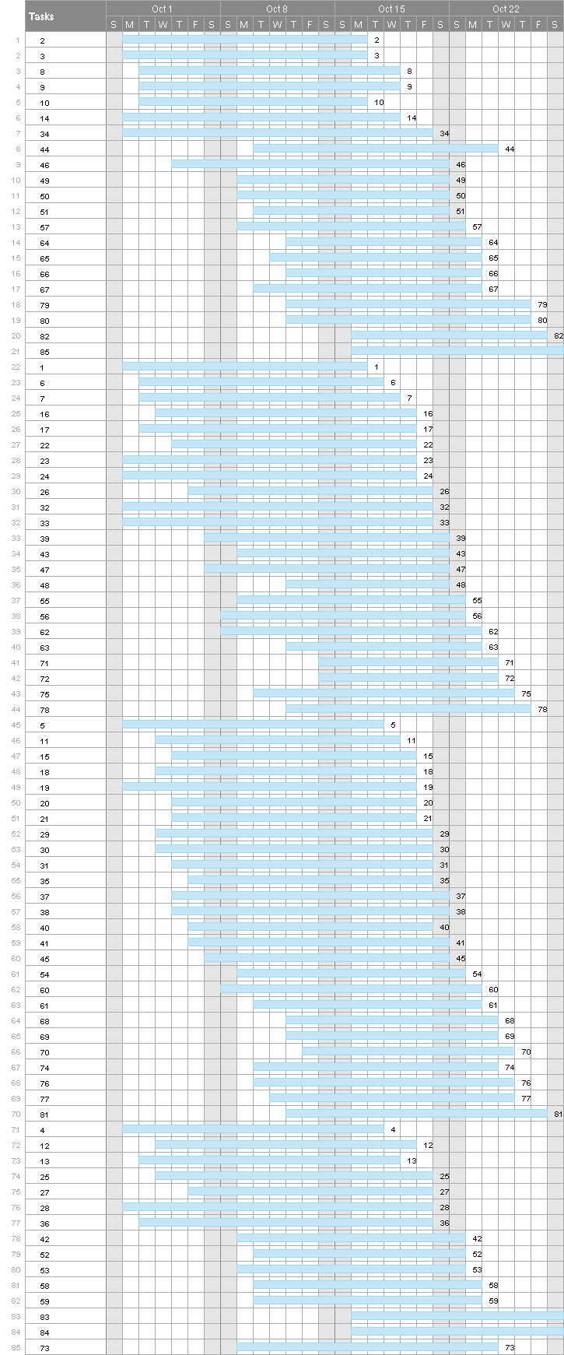

**

*Figure 1B. Quick Gantt Chart of Provided Dates in Assignment A (Early Start to Late Finish)*

# Conclusion

Group 7 (previously Group 8) would like to thank the instructor and TA’s time in reviewing this project update, and the group looks forward to completing the assignments this term. Should there be any questions, please do not hesitate to contact any group member.

Regards,

| Lily Ren |  |
| --- | --- |
| Suzana Trac |  |
| Haoran Liang |  |
| Owen Zhao |  |